This is a real time dataset of the ineuron technical consultant team. You have to perform hive analysis on this given dataset.

Download Dataset 1 - https://drive.google.com/file/d/1WrG-9qv6atP-W3P_-gYln1hHyFKRKMHP/view

Download Dataset 2 - M

Note: both files are csv files.

1. Create a schema based on the given dataset

Create table Agentlogreports

>(sl_no int,Agent string,Date string,Login string,Logout string,duration string) row format delimited fields terminated by ‘,’ tblproperties (“skip.header.line.count”=”1”);

>create table Agentperformance

>(sl_no int,date string,agent sring,totalchats int,average_response string,Average_resolution string,Average_rating float,total_feedback int) row formate delimited fields terminated by ‘,’ tblproperties(“skip.header.line.count”=”1”);

1. Dump the data inside the hdfs in the given schema location.

>load data inpath ‘/tmp/Reethesh_hive_challenge_hdfs/AgentlogingReport.csv into table Agentlogreports;

> load data inpath ‘/tmp/Reethesh_hive_challenge_hdfs/AgentPerformance.csv into table AgentPerformance;

1. List of all agents' names.

Select Agent from Agentlogreports;

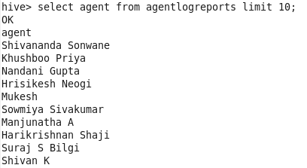

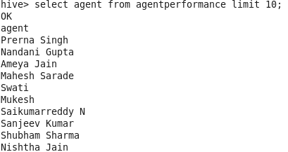

1. Find out agent average rating.

Select agent,avg(average_rating) as averagerating from agent_performance group by agent order by averagerating desc;

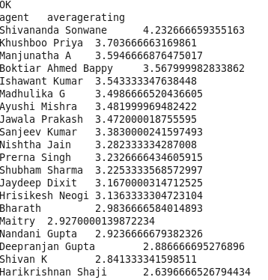

1. Total working days for each agents

Select agent,count(distinct date) as totalpresenteddays from agentlogreports group by agent order by totalpresenteddays desc;

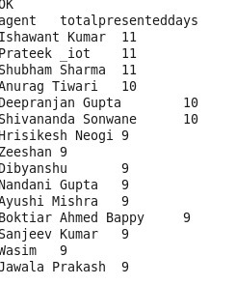

1. Total query that each agent have taken

Select agent,sum(total_chats)as totalquerryhandled from agentperformance group by agent order by totalquerryhandled desc limit 5;

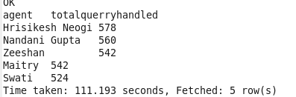

1. Total Feedback that each agent have received

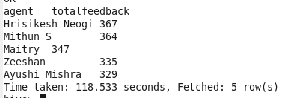

1. Agent name who have average rating between 3.5 to 4

Select agent,avg(average_rating) as averagerating from agentperformance where average_rating between 3.5 and 4 group by agent order by averagerating desc;

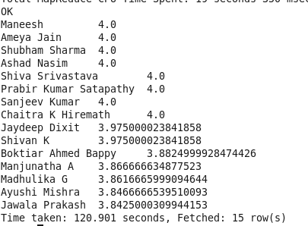

1. Agent name who have rating less than 3.5

Select agent,avg(average_rating) as avgrating from agentperformance group by agent having avg(average_rating)<3.5 order by avgrating desc;

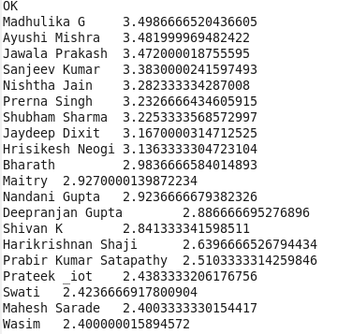

1. Agent name who have rating more than 4.5

Select agent,avg(average_rating) as avgrating from agentperformance where average_rating >3.5 group by agent order by avgrating ;

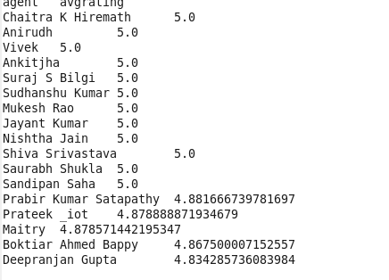

1. How many feedback agents have received more than 4.5 average

Select agent,avg(total_feedback) as avgfeedback from agentperformance group by agent having avg(total_feedback)>4.5 order by avgfeedback desc;

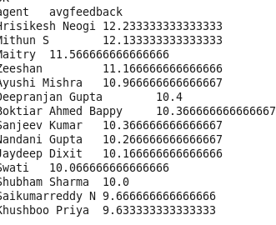

1. average weekly response time for each agent

Selectagent,avg(average_response[0]*3600+average_response[1]*60+substr(average_response[2],1,2))/3600 as avg from (select agent,split(average_response,’:’) as average_response from agentperformance)s group by agent order by avg desc;

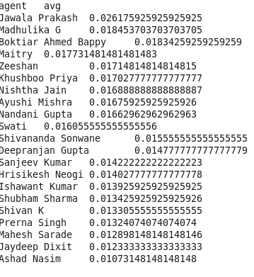

1. average weekly resolution time for each agents

Selectagent,avg(average_resolution[0]*3600+average_resolution[1]*60+substr(average_resolution[2],1,2))/3600 as average_resolution from (select agent,split(average_resolution,’:’) as average_resolution from agentperformance)s group by agent order by average_resolution desc;

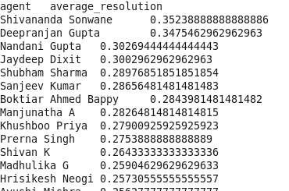

1. Find the number of chat on which they have received a feedback

Select agent,sum(total_chats) as total_chats from agentperformance where total_feedback!=0 group by agent,total_chats,total_feedback;

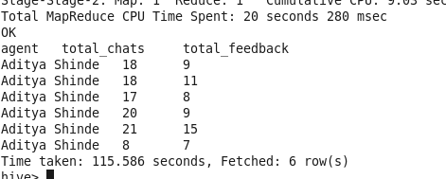

1. Total contribution hour for each and every agents weekly basis

Select agent,sum(r1[0]*3600+r1[1]*60+r1[2])/3600 as duration,week from select(agent,split(duration,’:’) as r1,WeekOfYear(date) as week from agentlogreports)s group by agent,duration limit3;

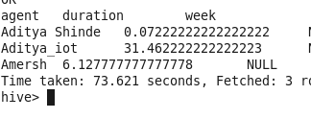

1. Perform inner join, left join and right join based on the agent column and after joining the table export that data into your local system.

**Inner join**

Select * from agentlogreports as a inner join agentperformance as b on a.agent=b.agent limit 3;

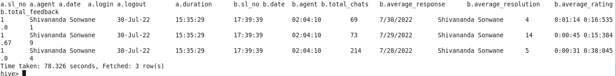

**Left join**

Select * from agentlogreports as a left

join agentperformance as b on a.agent=b.agent limit 3;

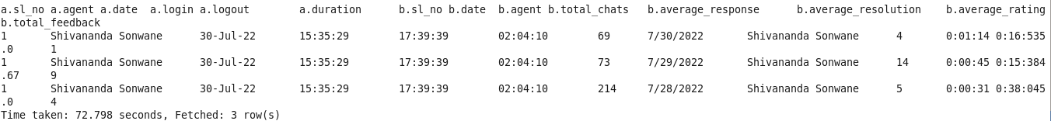

**Right join**

Select * from agentlogreports as a right join agentperformance as b on a.agent=b.agent limit 3;



**Ecport data into local as csv file (file path:/tmp/Reethesh_revision)**

**Cloudera terminal:**

Hive –e ‘select * from reethesh_mini_project.agentlogreports as a inner join agentperformance as b on a.agent = b. agent’ into out file /tmp/Reethesh_revision/inner_join.csv

Hive –e ‘select * from reethesh_mini_project.agentlogreports as a right join agentperformance as b on a.agent = b. agent’ into out file /tmp/Reethesh_revision/right_join.csv

Hive –e ‘select * from reethesh_mini_project.agentlogreports as a left join agentperformance as b on a.agent = b. agent’ into out file /tmp/Reethesh_revision/left_join.csv



17. Perform partitioning on top of the agent column and then on top of that perform bucketing for each partitioning

Create table AgentLogingReport_partitioned

(sl_no int,Date date,Login string,Logout string,Duration string)partitioned by (Agent string)Clustered by (Date) sorted by (date) into 4 BUCKETS

Row format delimited fields terminated by ',';

hive> set hive.exec.dynamic.partition=true;

hive> set hive.exec.dynamic.partition.mode=nonstrict;

hive> insert into table AgentLogingReport_partitioned partition(Agent) select sr_no,Date,Login,Logout,Duration,Agent from AgentLogingReport;

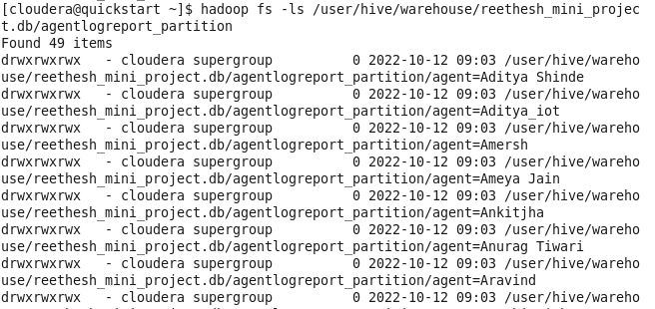

Hive> Create table AgentPerformance__partition

(sl_no int,Date date,total_chats string,Average_response string,

Average_Resolution string,Average_Rating float,total_Feedback int)partitioned by (Agent string)

Clustered by (Date) sorted by (Date) into 8 BUCKETS

Row format delimited fields terminated by ',';

Hive> insert into table AgentPerformance_partition partition(Agent) select sl_no,Date,Total_chats,Average_Response,Average_Resolution,Average_Rating,Total_Feedback,Agent from AgentPerformance;

